Larger questions

Marketplace Initiative Goa:
- What are we really trying to build here? Community, equipping people, or bringing change in the city? Is it one of these or a mix of these? And as a team, are we aligned on this?

Transformation in the Marketplace:
- How do we believe transformation really happens? Is it mainly through building a strong community, through people growing personally and influencing their workplaces, or through actively engaging beyond our circles?
- And how are we thinking about engaging with the wider city, not just within the Christian community?

Larger City Context:
- There’s already a lot happening in the marketplace space in the city. How well do we understand what’s already happening, and are we adding something distinct or unintentionally duplicating?
- And should we be building something new, or partnering with what already exists?

Monthly meetings:
- What are we really hoping will come out of them?
- Who are we trying to reach, and what makes this space meaningfully different from other networks people are already part of?
- And how is this actually translating into real impact beyond the meetings themselves?

Role of the App
- What is the intended purpose of the app within this larger vision?
- What outcomes are we hoping for in the lives of people who join the app?

- Vision and clarity of the MP initiative in Goa - Are we primarily building a Christian community within the marketplace, or are we forming and sending people to intentionally shape and transform the marketplace? Or is it both?
  - What is the long-term vision for the marketplace initiative? And how are our current meetings and activities intentionally working toward this long-term vision?
  - Is the team aligned in how we understand and pursue these goals?
  - If community is central, what kind of community are we building—social, supportive, or deeply formational?
  - If transformation is central, what are the clear pathways through which that transformation is expected to happen?
  - At its core, what is our primary vision:
    - Building a strong, relational Christian marketplace community?
    - Equipping and shaping individuals for influence and transformation in their workplaces?
    - Or intentionally catalyzing broader transformation in the marketplace and city?

- Clarity on the monthly MP meetings
  - What are we ultimately expecting to see come out of these marketplace meetings? Have we clearly defined the key objectives and desired outcomes for this space?
  - Who are we trying to reach through these meetings?
  - Many Christians are already meaningfully engaged in other professional and city-based networks.
What is the unique value or formation this marketplace space offers that they may not receive elsewhere?
  - Why should a Christian already thriving in external networks choose to invest time in this space?
  - What is distinct about what happens here that makes it worth their commitment?
  - In what tangible ways are we currently reaching or impacting the marketplace beyond the meetings themselves?
  - How does what happens in this space meaningfully translate into how people live, lead, and engage in their actual workplaces?
  - Are these gatherings meant to be primarily for believers, or are they also designed to include those outside the faith?
  - Is this initiative primarily intended to be a community space for connection among Christians in the marketplace?
  - Or is it meant to be something more formational and missional in nature?
3. Understanding the Existing Landscape
- What are the key initiatives, networks, or interventions already contributing to the transformation of the city?
- How well do we understand what is already happening in the marketplace space in the city?
- In light of what already exists, what is unique about our role as a marketplace community?
- What distinct value do we believe we are called to bring that may not currently be addressed?
- Are we unintentionally duplicating efforts that already exist?
- Or are we intentionally identifying and stepping into gaps that are currently unmet?
- Are there existing organizations or networks we could partner with instead of building from scratch?
- What might meaningful partnership look like in practice—co-creating, supporting, or strengthening what already exists?
- Given that the Christian community in the marketplace is relatively small, how do we steward our people and resources wisely?
- Where can we have the most meaningful and strategic impact rather than spreading ourselves thin?

4. Theory of Change (How Transformation Happens)
- How do we believe transformation in the marketplace actually happens?
- Are we primarily:
  - Building and discipling Christians in the marketplace to influence their own spheres?
  - Equipping individuals to actively engage and reach others in their workplaces?
  - Creating spaces that invite non-Christians into conversation and community?
- What does meaningful engagement with the wider city look like in this context?
- If our vision is city transformation, how are we engaging beyond the Christian community?
- Are we equipping people only within our circle, or also positioning them to contribute meaningfully within broader city initiatives?

Questions for BOR
And something like this for the BOR questions:

1. When you think about Marketplace as a group, what do you believe we are here to accomplish together?
2. What opportunities do you see for the Marketplace group to take up collectively?
3. How could we become more intentional about helping and learning from one another beyond simply coming together for meetings?
4. What kind of difference do you hope the Marketplace stream could make in the lives and work of the people involved, and perhaps beyond?
5. Has the formational journey of the past 8 months been useful to you in any way? If yes, how? If not, what would you like to hear about more at these meetings?

And something like this for the BOR questions:

1. When you think about Marketplace as a group, what do you believe we are here to accomplish together?
2. What opportunities do you see for the marketplace group?
3. How could we become more intentional about helping and learning from one another beyond simply coming together for meetings?
4. What kind of difference do you hope the Marketplace stream could make in the lives and work of the people involved, and perhaps beyond?
5. What would make you feel that Marketplace is becoming something truly valuable and significant?

Tab 4
Core session 1: What are we building? Why do we exist? (Clarify our purpose)
Core session 2: How does transformation happen? (TOC)
Core session 3: Where do we fit in Goa? (Our distinctive contribution, purpose of monthly meetings, etc.)
Concluding session: basically tying it all together

Working Draft

Core Session 1: What are we building? Why do we exist?
Central question: What is Faith in the Workplace Goa / the Marketplace stream actually here to build, and why?
What would change/ renewal look like?

 |  | Current | Renewed
Individuals | Professionals | Legal inability to advertise  Salary-centric, not service-centric  Lack of innovation  Slavery mindset | Spirit of excellence, people-centric, be service-centric, no sacred-secular divide,
 | Entrepreneurs | Focused on profits, performance  Lack of understanding of cashflow  Lack of quality staff/hiring  Lack of financial knowledge/business plan  Lack of menṭorship  Overcapital investment, requirement of investment of loan | See success as shaping culture, not simply profits/ performance  Entrepreneurs are linked to good mentors and investors  Job creators  Linking to unemployed and capable youth
 | Investors | Look for quick returns, imperfect knowledge of quality enterprise, difficult enforcement mechanism of repayment, NPAs, risk averse, thinking only in terms of financial return | Absorbing the cost, thinking in terms of social return, build redemptive businēsses, linking investors with good entrepreneurs,
 | Civil Servants | Bribes, lethargy, taking jobs for granted, jobs being bought - not given to deserving individuals, systemic corruption, ego and rudeness, entitlement | God- fearing, ethical, punctual, contentment, spirit of excellence, quality performance, posture of serving, not lording it over, need/context based systems and processes,
 | Employees | Unskilled, not resilient, not competent, not ambitious, toxic work cultures for employees, crab mentality, Burnout, overworked and underpaid employees | Healthy work environmenṭs, work-life balance, skilled employees, a sense of ownership, collaborative spirit, support systems, team spirit, empowered, Efficient, responsible,
 | Unemployed | Education not leading to jobs, comfort zone, too many job shifts, lack of self-awareness, lack of direction and guidance, lack of opportunities, | Knowledge of what they want to do. Confident about what they want to do, education system renewed, more opportunities,
Groups (sectors) | Women
 | Hospitality | Lack of understanding of the meaning of hospitality, | Standards and compliances mainṭainēd, focus on kitchen (hygiene and sanitation), good etiquette and manners, helpfulness of the hospitality, food safety and not simply food tasty
 | Manufacturing | No proper standards and compliance, safety measures not followed, enviromenṭ standards, lack of accounṭability and regard for human life. | regulatory customised and nōt standardised, investors embracing manufacturers as partnērs, safely disposing toxic wastes, safe working conditionś,
 | Travel and tourism
 | Real estate
 | Education
 | Medical
 | Church
 | Differently abled
 | Young people | lack of education, discipline, concentration, dreams, vision, instant gratification. Looking for quick money, “I know” problems, | Focused, envisioned, deferred gratification, skilled, financial knowledge, learning a trade,
Theology | On the Marketplace | Sacred-secular divide, money is evil (onl̥y if it does not fund), “don’t work God will provide”, MP exists to fund the mission, | Stewardship, a sense of ownership from the church, a culture of genērosity, culture of giving without expecting in return.
Structures | In relation to the marketplace | Discrimination againśt women and language, exploitation of human beings, reality of caste anḍ community, policies exist but lack of implementation of policies, bribery, lack of good policy makers, | SOPs for the issues, Goa’s responsibility to the rest of the counṭry.
Missional

What seems to be emerging already
1. We are building a community, not just a programme.
- Bring people together.
- Build meaningful relationships.
- Build trust and community.
- Create a space where people journey together rather than operate in isolation.
- Monthly gatherings should be more than networking or inspirational meetings.
- The relational dimension is foundational.
2. We are building a Kingdom movement, rather than an organisation.
You raised an important distinction:
A Kingdom movement is interested in the final goal and vision; an organisation can become primarily interested in its own name or credit.
This seems to suggest that the Marketplace stream exists for the sake of transformation in the Marketplace and ultimately Goa, rather than for the growth, recognition, or credit of the Marketplace group itself.
That raises a really useful question for the session:
What would we be willing to see happen even if our group didn't get the credit for it?
3. Renewal is part of our distinctive identity.

You identified renewal as something particularly important to the Marketplace stream.
The goal isn't simply:
- better businesses
- successful entrepreneurs
- professional networking
- business skills
It is also about people being personally renewed and transformed in how they understand and practise faith and work.
So there appears to be a movement from:
personal renewal → transformed people → transformed workplaces/businesses → wider Marketplace transformation.

A possible emerging purpose
Not yet a final statement, but the conversation seems to be pointing toward something like:
To build a community of people whose lives and work are renewed by Christ, who grow together, and who contribute to the transformation and flourishing of Goa's Marketplace.

Core Session 2: How does transformation happen?
Central question: What is our theory of change? If this is what we want to see, how do we believe it actually happens?
This is where a lot of your material fits.

1. Personal renewal/transformation
People themselves are the starting point.
Transformation involves:
- character
- purpose
- faith
- leadership
- competence
- wisdom
- how people understand work
- how they make decisions
- how they lead
This is more than giving people information.
Renewal → changed people → changed behaviour.

2. Community and relationships
Transformation doesn't happen in isolation.
Community provides:
- encouragement
- accountability
- honest conversations
- mentorship
- peer learning
- emotional/spiritual support
- shared problem-solving
- collaboration
So:
Relationship → trust → mutual support → growth → transformation.
This is why community isn't just a nice by-product of the Marketplace stream. It is part of the mechanism of transformation.

3. Equipping
You have identified three practical areas/nuggets:

A. Incubators
For people starting businesses.
Potential focus:
- developing the idea
- entrepreneurship
- foundational business skills
- building a viable business

B. Accelerators
For existing business owners.
Potential focus:
- business challenges
- growth
- scaling
- sustainability
- leadership
- solving current business problems

C. Discipline / Production / AI & Productivity
For people wanting to do better in business/work.
This seems to encompass practical workplace capability — including things like AI, productivity, professional excellence, etc.
So the equipping pathway might eventually look something like:
START → GROW → EXCEL
or
INCUBATE → ACCELERATE → EQUIP
I'd keep the exact terminology open for now because your team seems still to be discerning what belongs in that third "nugget."

4. Faith integration
You also identified another major area:
Faith in the Marketplace
This includes:
- ethics
- Marketplace principles
- integrity
- understanding faith and work
- applying Christian principles to business
- workplace culture
- leadership
So transformation isn't simply:
"Become a better Christian and become a better businessperson."
It's about integrating the two.

5. Collaboration
Collaboration seems to be both a method and an outcome.
People collaborate when there is:
- alignment
- shared values
- common ground
- trust
And collaboration then enables:
- shared learning
- solving problems
- innovation
- partnerships
- projects
- wider impact
So you might eventually have a TOC pathway something like:
Renewal → Community → Equipping → Collaboration → Transformation
But I wouldn't lock that in yet. The core team should test whether that's actually how you understand transformation.

Core Session 3: Where do we fit in Goa?
Central question: Why do we need this? What is our distinctive contribution within the existing Marketplace ecosystem?
This is where your "concentric circles" thinking and your desire not to duplicate existing initiatives fit particularly well.

1. We are not starting from zero
You already recognise that there are:
- businesses
- entrepreneurs
- professional networks
- Christian initiatives
- training programmes
- organisations
- existing Marketplace work
So the first task is to understand what already exists.
Then ask:
Where are the genuine gaps?

2. Our distinctive contribution may be the integration of several things
Rather than being another business network or another training programme, you're beginning to identify an intersection:
Faith + Renewal + Community + Business Growth + Collaboration + City Transformation
That combination may be where the distinctiveness lies.
Especially:
We don't just want to help people do business better. We want to see people renewed in how they live out their faith and work, while also helping them grow and contribute to the wider Marketplace.

3. We collaborate from alignment, not necessarily total agreement
Your concentric-circle idea fits here.
Centre:
People with deep alignment around vision, values and mission.
Middle:
Broader Marketplace community participating in relationship, learning and collaboration.
Outer:
Strategic partnerships with people/organisations beyond the Christian community around shared concerns and the common good.
This gives you a way of thinking about how you relate to the wider Goa ecosystem without becoming either isolated or diluted.

4. Purpose of monthly gatherings
The monthly gathering therefore isn't the end goal.
It is a vehicle for:
Relationship → Trust → Formation → Equipping → Collaboration → Action
The gathering should potentially accomplish several things:
- build relationships
- deepen trust
- create space for renewal
- discuss real Marketplace issues
- equip people
- surface challenges
- connect people with one another
- generate collaboration
- identify opportunities for action
And then the real question becomes:
What happens between meetings because of what happened at the meeting?
That's probably an important question for Session 3.

Concluding Session: So, what are we actually building?
The concluding session can pull the previous three together.
I'd imagine the team arriving at a simple chain:

WHY
Why do we exist?
↓

WHO
Who are we seeking to become/build?
↓

HOW
How do we believe transformation happens?
↓

WHAT
What do we actually do?
↓

WHERE
Where do we contribute within Goa's wider Marketplace ecosystem?
↓

IMPACT
What would we expect to see change if this is working?

And I think your existing thinking currently falls into this rough picture:
Question | What you have already surfaced
What are we building? | A Kingdom-oriented Marketplace community; a movement rather than an organisation; a community built on relationships, trust and shared vision
Why do we exist? | To see people renewed/transformed in their faith and work, grow in business/professional capability, and contribute to Marketplace/city transformation
How does transformation happen? | Personal renewal + community + equipping + faith integration + collaboration → transformation
What does equipping look like? | Incubators for entrepreneurs; accelerators for business owners; productivity/discipline/AI-type equipping for people wanting to do better in work/business
What does faith integration look like? | Ethics, Marketplace principles, integrity, leadership, applying faith to real business/work situations
How does collaboration happen? | Through relationships, trust, alignment and common ground
Where do we fit in Goa? | Complement existing initiatives rather than compete; identify gaps; build partnerships; contribute a distinctive integration of faith, formation, community and Marketplace transformation
What are monthly meetings for? | Relationships, trust, renewal, learning, equipping, problem-solving, collaboration and generating action beyond the meetings
How do we think about wider partnerships? | Expanding concentric circles — deeper alignment at the centre, broader collaboration around shared concerns/common good
How will we know we're making a difference?

Conversations so far

Core Session 1: What are we building? Why do we exist?
Central question: What is Faith in the Workplace Goa / the Marketplace stream actually here to build, and why?

What seems to be emerging already
1. We are building a community, not just a programme.
- Bring people together.
- Build meaningful relationships.
- Build trust and community.
- Create a space where people journey together rather than operate in isolation.
- Monthly gatherings should be more than networking or inspirational meetings.
- The relational dimension is foundational.
2. We are building a Kingdom movement, rather than an organisation.
You raised an important distinction:
A Kingdom movement is interested in the final goal and vision; an organisation can become primarily interested in its own name or credit.
This seems to suggest that the Marketplace stream exists for the sake of transformation in the Marketplace and ultimately Goa, rather than for the growth, recognition, or credit of the Marketplace group itself.
That raises a really useful question for the session:
What would we be willing to see happen even if our group didn't get the credit for it?
3. Renewal is part of our distinctive identity.
You identified renewal as something particularly important to the Marketplace stream.
The goal isn't simply:
- better businesses
- successful entrepreneurs
- professional networking
- business skills
It is also about people being personally renewed and transformed in how they understand and practise faith and work.
So there appears to be a movement from:
personal renewal → transformed people → transformed workplaces/businesses → wider Marketplace transformation.

A possible emerging purpose
Not yet a final statement, but the conversation seems to be pointing toward something like:
To build a community of people whose lives and work are renewed by Christ, who grow together, and who contribute to the transformation and flourishing of Goa's Marketplace.

Core Session 2: How does transformation happen?
Central question: What is our theory of change? If this is what we want to see, how do we believe it actually happens?
This is where a lot of your material fits.

1. Personal renewal/transformation
People themselves are the starting point.
Transformation involves:
- character
- purpose
- faith
- leadership
- competence
- wisdom
- how people understand work
- how they make decisions
- how they lead
This is more than giving people information.
Renewal → changed people → changed behaviour.

2. Community and relationships
Transformation doesn't happen in isolation.
Community provides:
- encouragement
- accountability
- honest conversations
- mentorship
- peer learning
- emotional/spiritual support
- shared problem-solving
- collaboration
So:
Relationship → trust → mutual support → growth → transformation.
This is why community isn't just a nice by-product of the Marketplace stream. It is part of the mechanism of transformation.

3. Equipping
You have identified three practical areas/nuggets:

A. Incubators
For people starting businesses.
Potential focus:
- developing the idea
- entrepreneurship
- foundational business skills
- building a viable business

B. Accelerators
For existing business owners.
Potential focus:
- business challenges
- growth
- scaling
- sustainability
- leadership
- solving current business problems

C. Discipline / Production / AI & Productivity
For people wanting to do better in business/work.
This seems to encompass practical workplace capability — including things like AI, productivity, professional excellence, etc.
So the equipping pathway might eventually look something like:
START → GROW → EXCEL
or
INCUBATE → ACCELERATE → EQUIP
I'd keep the exact terminology open for now because your team seems still to be discerning what belongs in that third "nugget."

4. Faith integration
You also identified another major area:
Faith in the Marketplace
This includes:
- ethics
- Marketplace principles
- integrity
- understanding faith and work
- applying Christian principles to business
- workplace culture
- leadership
So transformation isn't simply:
"Become a better Christian and become a better businessperson."
It's about integrating the two.

5. Collaboration
Collaboration seems to be both a method and an outcome.
People collaborate when there is:
- alignment
- shared values
- common ground
- trust
And collaboration then enables:
- shared learning
- solving problems
- innovation
- partnerships
- projects
- wider impact
So you might eventually have a TOC pathway something like:
Renewal → Community → Equipping → Collaboration → Transformation
But I wouldn't lock that in yet. The core team should test whether that's actually how you understand transformation.

Core Session 3: Where do we fit in Goa?
Central question: Why do we need this? What is our distinctive contribution within the existing Marketplace ecosystem?
This is where your "concentric circles" thinking and your desire not to duplicate existing initiatives fit particularly well.

1. We are not starting from zero
You already recognise that there are:
- businesses
- entrepreneurs
- professional networks
- Christian initiatives
- training programmes
- organisations
- existing Marketplace work
So the first task is to understand what already exists.
Then ask:
Where are the genuine gaps?

2. Our distinctive contribution may be the integration of several things
Rather than being another business network or another training programme, you're beginning to identify an intersection:
Faith + Renewal + Community + Business Growth + Collaboration + City Transformation
That combination may be where the distinctiveness lies.
Especially:
We don't just want to help people do business better. We want to see people renewed in how they live out their faith and work, while also helping them grow and contribute to the wider Marketplace.

3. We collaborate from alignment, not necessarily total agreement
Your concentric-circle idea fits here.
Centre:
People with deep alignment around vision, values and mission.
Middle:
Broader Marketplace community participating in relationship, learning and collaboration.
Outer:
Strategic partnerships with people/organisations beyond the Christian community around shared concerns and the common good.
This gives you a way of thinking about how you relate to the wider Goa ecosystem without becoming either isolated or diluted.

4. Purpose of monthly gatherings
The monthly gathering therefore isn't the end goal.
It is a vehicle for:
Relationship → Trust → Formation → Equipping → Collaboration → Action
The gathering should potentially accomplish several things:
- build relationships
- deepen trust
- create space for renewal
- discuss real Marketplace issues
- equip people
- surface challenges
- connect people with one another
- generate collaboration
- identify opportunities for action
And then the real question becomes:
What happens between meetings because of what happened at the meeting?
That's probably an important question for Session 3.

Concluding Session: So, what are we actually building?
The concluding session can pull the previous three together.
I'd imagine the team arriving at a simple chain:

WHY
Why do we exist?
↓

WHO
Who are we seeking to become/build?
↓

HOW
How do we believe transformation happens?
↓

WHAT
What do we actually do?
↓

WHERE
Where do we contribute within Goa's wider Marketplace ecosystem?
↓

IMPACT
What would we expect to see change if this is working?

And I think your existing thinking currently falls into this rough picture:
Question | What you have already surfaced
What are we building? | A Kingdom-oriented Marketplace community; a movement rather than an organisation; a community built on relationships, trust and shared vision
Why do we exist? | To see people renewed/transformed in their faith and work, grow in business/professional capability, and contribute to Marketplace/city transformation
How does transformation happen? | Personal renewal + community + equipping + faith integration + collaboration → transformation
What does equipping look like? | Incubators for entrepreneurs; accelerators for business owners; productivity/discipline/AI-type equipping for people wanting to do better in work/business
What does faith integration look like? | Ethics, Marketplace principles, integrity, leadership, applying faith to real business/work situations
How does collaboration happen? | Through relationships, trust, alignment and common ground
Where do we fit in Goa? | Complement existing initiatives rather than compete; identify gaps; build partnerships; contribute a distinctive integration of faith, formation, community and Marketplace transformation
What are monthly meetings for? | Relationships, trust, renewal, learning, equipping, problem-solving, collaboration and generating action beyond the meetings
How do we think about wider partnerships? | Expanding concentric circles — deeper alignment at the centre, broader collaboration around shared concerns/common good
How will we know we're making a difference?

Tab 5 - Session 1 notes

What kind of Marketplace are we dreaming of?
When I look across everything you've shared, I see several big vision themes emerging.

1. PEOPLE ARE RENEWED
People become:
- ethical
- excellent
- competent
- responsible
- resilient
- purposeful
- generous
- servant-hearted
- collaborative
- empowered

2. WORK IS RENEWED
Work becomes:
- meaningful
- service-oriented
- people-centred
- excellent
- dignified
- integrated with faith
- a place for contribution rather than merely income

3. BUSINESSES ARE RENEWED
Businesses become:
- sustainable
- ethical
- culture-shaping
- job-creating
- socially responsible
- innovative
- capable of generating social as well as financial return

4. RELATIONSHIPS ARE RENEWED
The Marketplace becomes characterised by:
- mentorship
- trust
- collaboration
- shared learning
- partnership
- generosity
- people helping one another succeed

5. SYSTEMS ARE RENEWED
You have also started thinking beyond individuals:
- better policies
- implementation of policies
- appropriate standards
- safety
- accountability
- reduced corruption
- contextualised systems
- dignity and non-discrimination

6. THE CHURCH'S UNDERSTANDING OF THE MARKETPLACE IS RENEWED
This is your theology piece:
Marketplace isn't merely a source of money for ministry.
It is itself a sphere of God's purposes, stewardship, service, creativity, contribution and transformation.

Move toward a Vision Statement
Don't ask "How will we do this?" yet.
Instead, ask:
If God were renewing Goa's Marketplace, what would we see?
You could put your emerging vision into one broad picture:

A renewed Marketplace where...
people are transformed in character, competence, purpose and faith;
work and business are pursued with excellence, integrity, service and stewardship;
businesses create value, opportunity and social good rather than pursuing profit alone;
relationships are marked by trust, mentorship, generosity and collaboration;
systems and institutions increasingly reflect justice, dignity, accountability and responsibility;
and Christians understand and live out their faith in the Marketplace as an arena for meaningful contribution and transformation.
That's not your final vision statement. It's the vision territory you've already uncovered.

4. Core Identity: What Are We Building?
The Marketplace stream exists to answer a fundamental question: What would it look like if the Gospel truly transformed how Goa does business, creates wealth, employs people, and shapes economic life?

4.1 A Community, Not Just a Programme
We are building a relational community where people journey together — not a series of events or training sessions. Monthly gatherings are vehicles for relationship, trust, formation, and collaboration, not ends in themselves. The relational dimension is foundational to everything we do.

4.2 A Kingdom Movement, Not an Organisation
We are interested in the final goal — the transformation of Goa's Marketplace — rather than the growth, recognition, or credit of the Marketplace group itself. A Kingdom movement asks: What would we be willing to see happen even if our group didn't get the credit for it?

4.3 Renewal as Our Distinctive Identity
We are not simply a business network, a professional association, or a training programme. Our distinctive contribution is the integration of personal renewal with marketplace equipping and city transformation. The goal is not merely better businesses or successful entrepreneurs — it is people being personally renewed and transformed in how they understand and practise faith and work.
The movement flows from:
• Personal renewal
→ Transformed people
→ Transformed workplaces and businesses
→ Wider Marketplace transformation
→ A flourishing Goa

9. Values and Fractals
These are the non-negotiable values that should be present at every level and scale of the movement — from the core team meeting to the largest gathering, from an incubator cohort to an investor roundtable.

• Kingdom First — we seek the Kingdom of God above the growth, recognition, or credit of this movement
• Renewal — we believe transformation begins with the personal renewal of individuals by Christ
As Personal renewal happens
→ Transformed people
→ Transformed workplaces and businesses
→ Wider Marketplace transformation
→ A flourishing Goa
• Integration — we refuse the sacred-secular divide and pursue the integration of faith and work in all areas
• Community — we are committed to deep, trust-based relationships as the foundation of transformation
• Stewardship — we hold all resources, gifts, relationships, and influence as stewards, not owners
• Excellence — we pursue excellence in all things as an expression of worship and a witness to the city
• Collaboration — we seek to complement, connect, and catalyse rather than compete or duplicate
• Generosity — we cultivate a culture of giving — time, expertise, capital, and networks — without expecting in return
• Inclusion: We welcome every Christian who shares the same vision and values without discriminating on the grounds of language, gender, sector, race, etc. to collaborative participation in the activities of the marketplace movement
As a MP group, we are a group of Christians, catering primarily to the christian community, but also working for the benefit of everyone in the city (irrespective of gender, religion, sector, race, etc), and through collaborations with other Christian and non-Christian groups
Leadership - ONLY CHRISTIANS
Transformation of the city - through collaborationś with other communities
Beneficiary - everyone in the city, irrespective of religion, etc.
Memberships - who are members?
• Humility — we hold our plans loosely, learn from others, and remain open to the Spirit's redirection

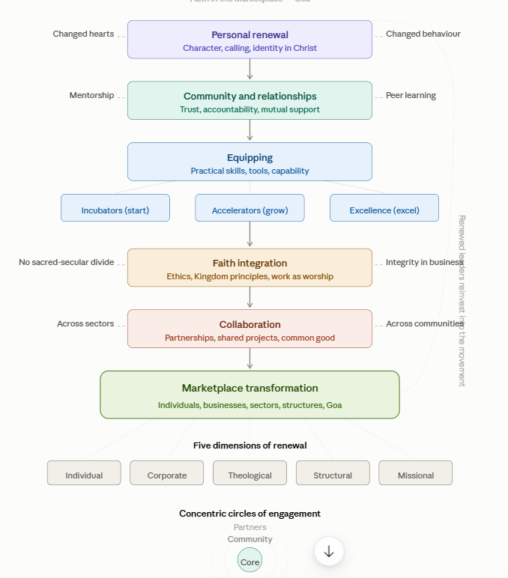

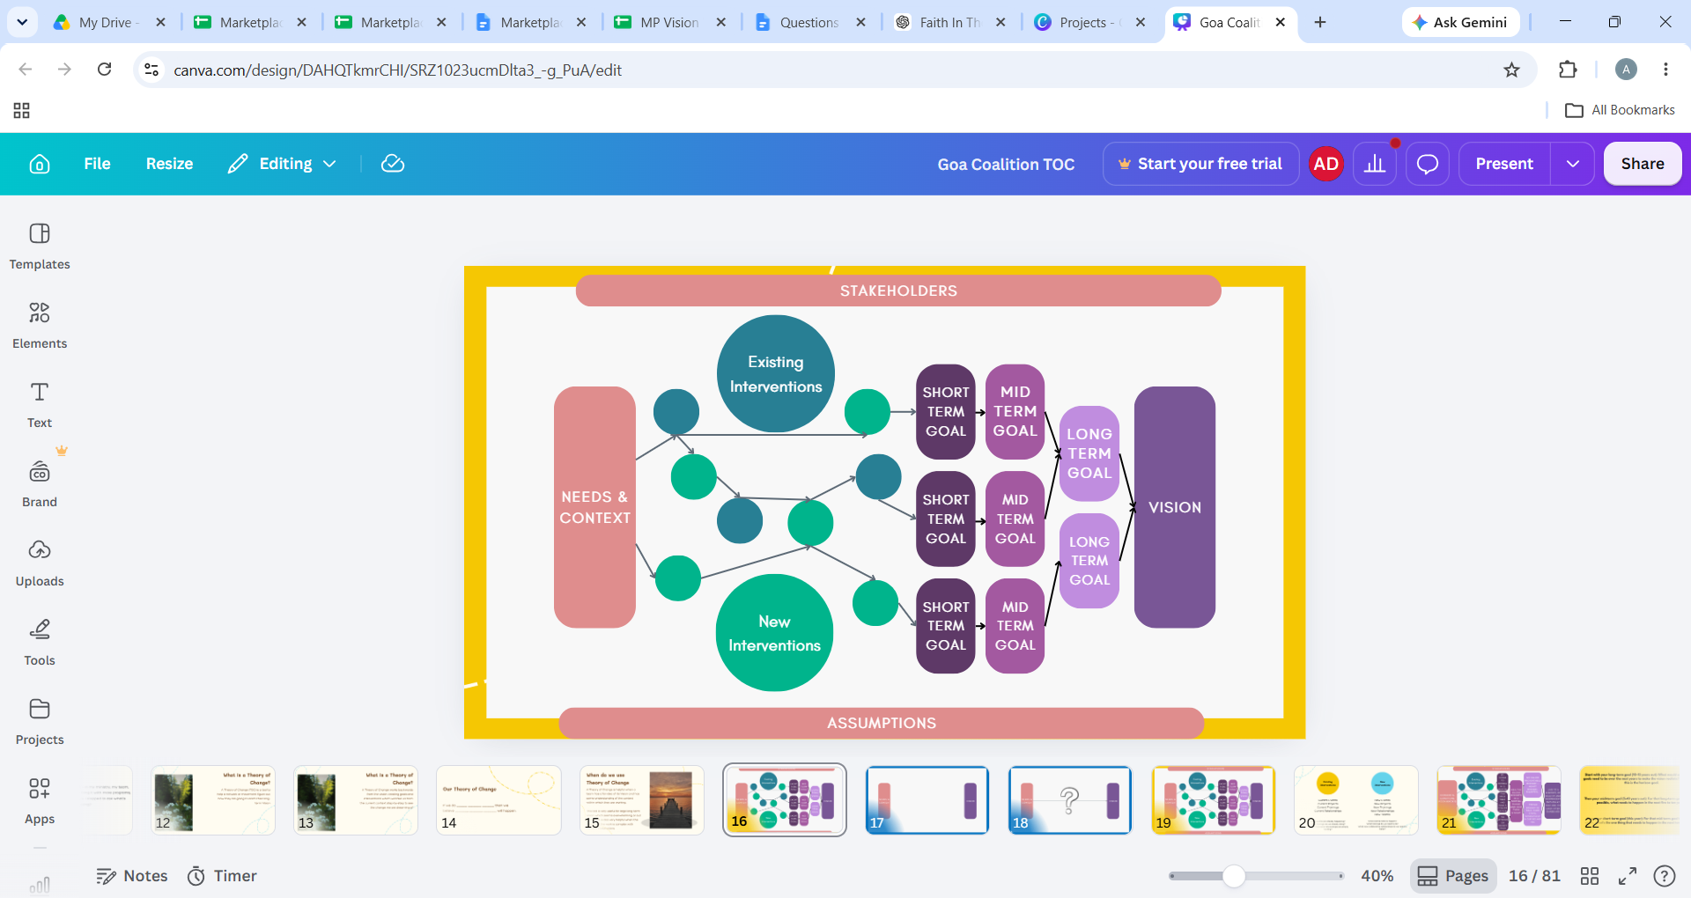

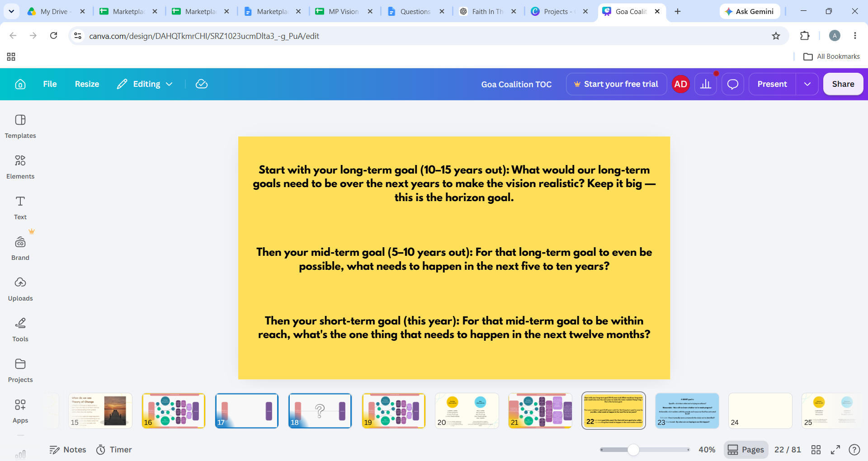

Tab 6 - Session 2 notes
HOW DOES TRANSFORMATION HAPPEN?

A renewed Marketplace where...
people are transformed in character, competence, purpose and faith;
Category of people we want to focus on: Entrepreneurs, professionals, inventors, youth, unemployed, employees

 |  | Current | Renewed | How?
People | Professionals | Legal inability to advertise  Salary-centric, not service-centric  Lack of innovation  Slavery mindset | Spirit of excellence, people-centric, be service-centric, no sacred-secular divide,
 | Investors | Look for quick returns, imperfect knowledge of quality enterprise, difficult enforcement mechanism of repayment, NPAs, risk averse, thinking only in terms of financial return | Absorbing the cost, thinking in terms of social return, build redemptive businēsses, linking investors with good entrepreneurs,
 | Civil Servants | Bribes, lethargy, taking jobs for granted, jobs being bought - not given to deserving individuals, systemic corruption, ego and rudeness, entitlement | God- fearing, ethical, punctual, contentment, spirit of excellence, quality performance, posture of serving, not lording it over, need/context based systems and processes,
 | Employees | Unskilled, not resilient, not competent, not ambitious, toxic work cultures for employees, crab mentality, Burnout, overworked and underpaid employees | Healthy work environmenṭs, work-life balance, skilled employees, a sense of ownership, collaborative spirit, support systems, team spirit, empowered, Efficient, responsible,
 | Unemployed | Education not leading to jobs, comfort zone, too many job shifts, lack of self-awareness, lack of direction and guidance, lack of opportunities, | Knowledge of what they want to do. Confident about what they want to do, education system renewed, more opportunities,
 | Youth | lack of education, discipline, concentration, dreams, vision, instant gratification. Looking for quick money, “I know” problems, | Focused, envisioned, deferred gratification, skilled, financial knowledge, learning a trade, | Skill trainings, menṭorship

work and business are pursued with excellence, integrity, service and stewardship;

Upskilling trainings for painters, masons, (contractors)

businesses create value, opportunity and social good rather than pursuing profit alone;

 | Entrepreneurs | Focused on profits, performance  Lack of understanding of cashflow  Lack of quality staff/hiring  Lack of financial knowledge/business plan  Lack of menṭorship  Overcapital investment, requirement of investment of loan | See success as shaping culture, not simply profits/ performance  Entrepreneurs are linked to good mentors and investors  Job creators  Linking to unemployed and capable youth | Formation pathways, incubator (praxis, joycorps,) Bryan (incubator of incubators)

relationships are marked by trust, mentorship, generosity and collaboration;
systems and institutions increasingly reflect justice, dignity, accountability and responsibility;
and Christians understand and live out their faith in the Marketplace as an arena for meaningful contribution and transformation.

Churches | 15 min presenṭation in each church.  Plus short Training - on work ethics, work culture.  Collect data of employees, data of businēsses, data of who can add value to add to the MP, looking for jobs (unemployed, or change of job),  Looking to be an entrepreneur

Marketing strategy for all the workshops - what does it mean for each sector? Club two sectors together.

Short term Goal (what we want to see happen in the nēxt 1 year) | How? | Mid term goals (what we want to see in the next 5 years) | How? | Long term goal (what do we want to see in the nēxt 10 years) | How?
Visibility | AGPLA meetings  One-to-many approach, one to one approach,  Exhibition / job fair (intention to collect data for us),  Form support groups | Growing in participation in the movement |  | 5 new businesses <10lakhs  5 new businesses 10-50 lakhs  5 new Christian businesses start and then scale up (minimum turnover of 50 lakhs)
Directory of everyonē in the MP | Data collection  Collect data of employees, data of businēsses, data of who can add value to add to the MP, looking for jobs (unemployed, or change of job), | Formation of subgroups and chapters |  | 500 -1000 new “members”
Envision and Involve the group | Clarifying the vision with the larger group | Equipping people | Workshops | Christian IAS officer from Goa | Coaching academy
5 Businesses need to improve in terms of revenue | Assessment and Mentor-coaching, Accelerator program | Helping current entrepreneurs grow | Incubators | Link investors to startups to scale up to >50cr
 |  | Developing a pool of corporate trainers to build capacity in the marketplace | Training of trainers | Equipping youth | Aspire

Tab 7 - Roles
Core Team Roles
Create roles such as:
1. Church & Pastor Relations (representation and communication with churches) - John, Stevens
2. Membership, Member Care & Community - Pradeep, Jason
3. Monthly Gatherings, - Atasha, Fiona
4. Industry/Sector Engagement - Jason, John, Caesar
5. Training & Equipping - Pradeep, Chef Prasad
6. Partnerships & Collaboration, - Sunita, Fiona
7. Monthly Communications - Sunita, Stevens
8. Mentoring - Caesar, Chef Prasad

